**Zainab Shahzad**

**SAP ID 56108**

**HCI LAB 4**

**Submitted to: Mam Sidra**

**INTERFACE 01:**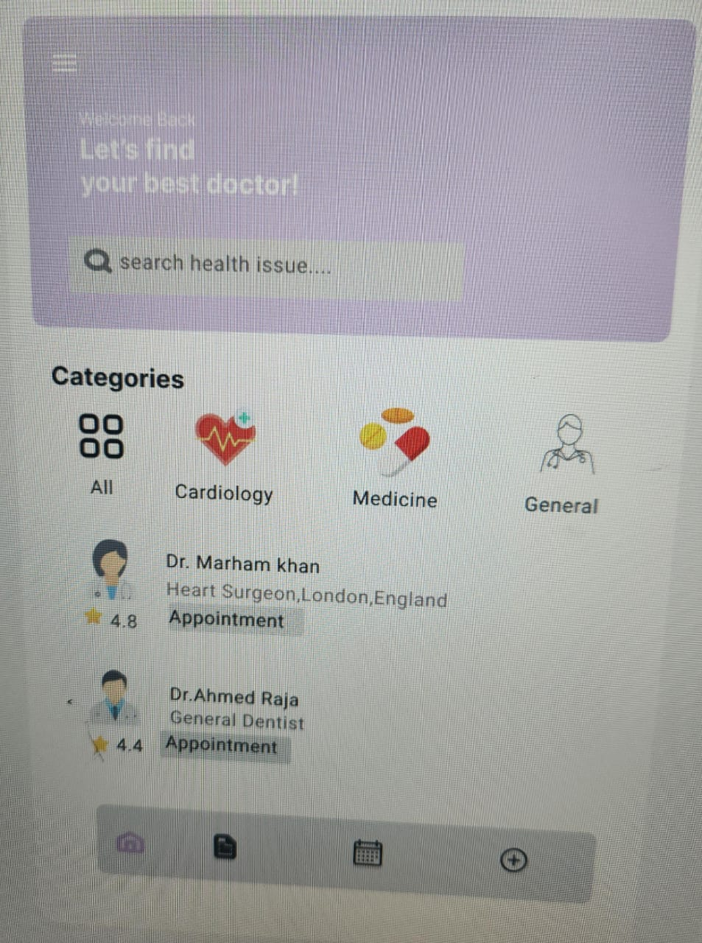

**INTERFACE 02**

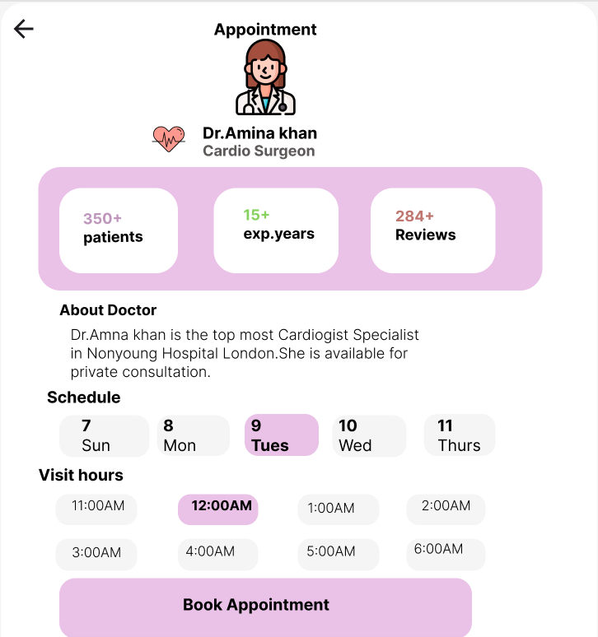**LINK:** https://www.figma.com/design/iu0UcG80xYtCv1sNe6hHGu/Untitled?node-id=0-1&p=f&t=ZQQ1s0Myl6WCdxg7-0